Supplemental Data

The main figures in the paper analysing the 21 high income countries selected by White were repeated using all the countries in the Human Mortality Database for which data were available (see Figure 1).

Figure 1 Data Availability for all 40 countries of the Human Mortality Database.

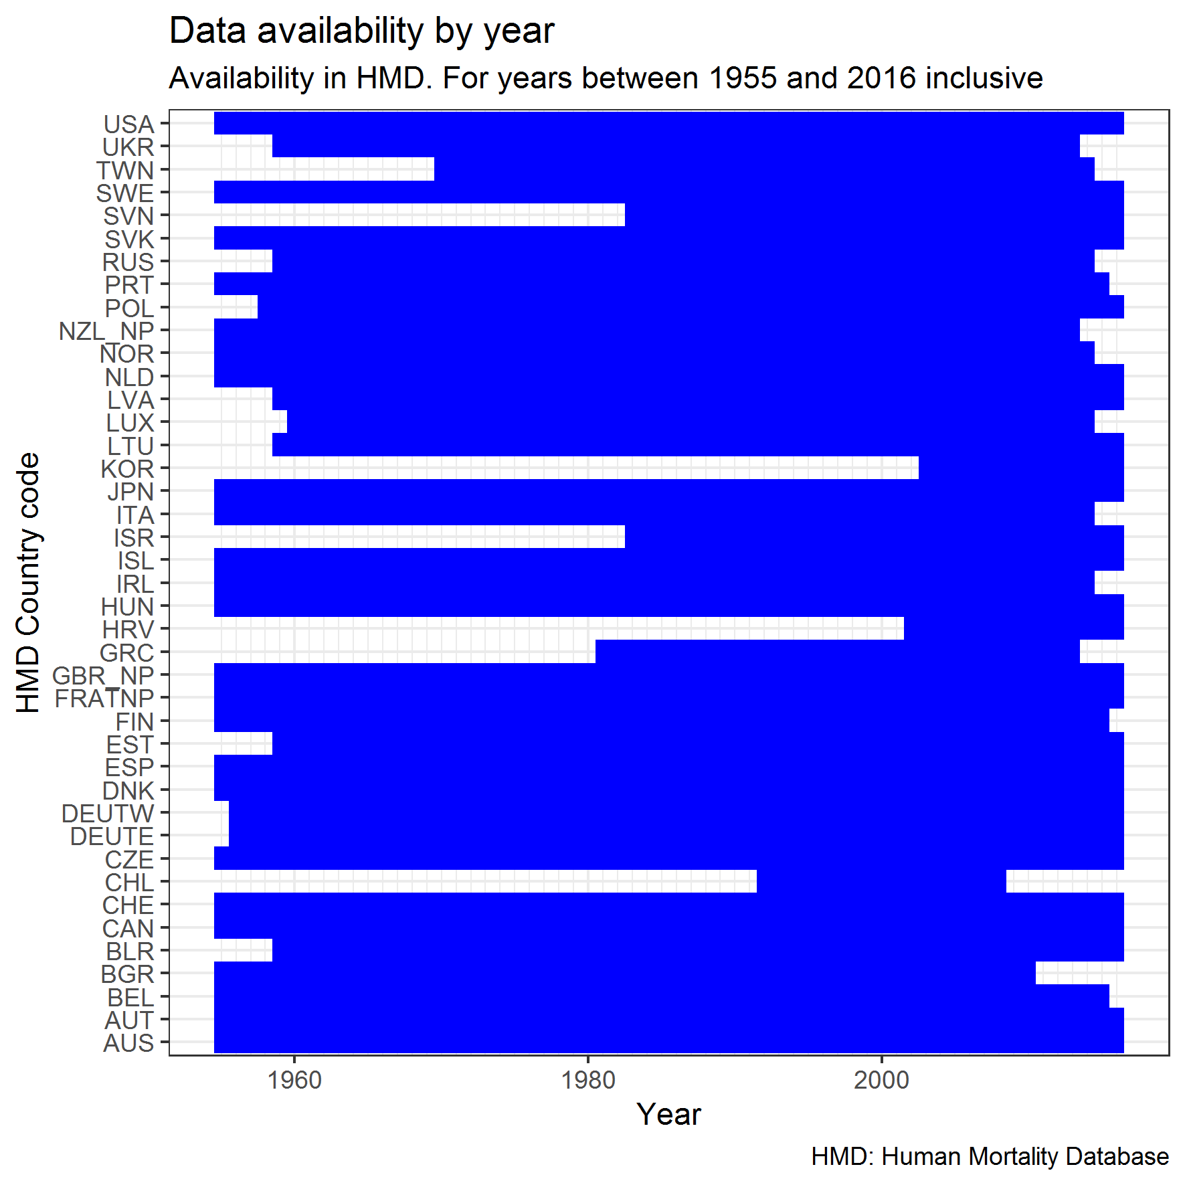

Table 1: R squared values of life expectancy at birth in 1955 for all 40 HMD countries against average annual gain in life expectancy per year between 1955 and 2016.

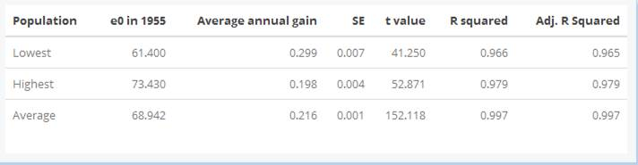

Table 2: key to country codes

|  |  |  |
| --- | --- | --- |
| **Code** | **Income Level** | **Country** |
| AUS | High Income | Australia |
| AUT | High Income | Austria |
| BEL | High Income | Belgium |
| CAN | High Income | Canada |
| CHE | High Income | Switzerland |
| DEUTW | High Income | West Germany |
| DNK | High Income | Denmark |
| ESP | High Income | Spain |
| FIN | High Income | Finland |
| FRATNP | High Income | France (total population) |
| GBR_NP | High Income | United Kingdom (total population) |
| GRC | High Income | Greece |
| IRL | High Income | Ireland |
| ITA | High Income | Italy |
| JPN | High Income | Japan |
| NLD | High Income | Netherlands |
| NOR | High Income | Norway |
| NZL_NP | High Income | New Zealand (total population) |
| PRT | High Income | Portugal |
| SWE | High Income | Sweden |
| USA | High Income | United States of America |
| BGR | Other | Bulgaria |
| BLR | Other | Belarus |
| CHL | Other | Chile |
| CZE | Other | Czechia |
| DEUTE | Other | East Germany |
| EST | Other | Estonia |
| HRV | Other | Croatia |
| HUN | Other | Hungary |
| ISL | Other | Iceland |
| ISR | Other | Israel |
| KOR | Other | Korea |
| LTU | Other | Lithuania |
| LUX | Other | Luxembourg |
| LVA | Other | Latvia |
| POL | Other | Poland |
| RUS | Other | Russia |
| SVK | Other | Slovakia |
| SVN | Other | Slovenia |
| TWN | Other | Taiwan |
| UKR | Other | Ukraine |

Figure 2 life expectancy against average annual change in life expectancy over 6 decades with all 40 HMD countries (an alternative Figure 3)

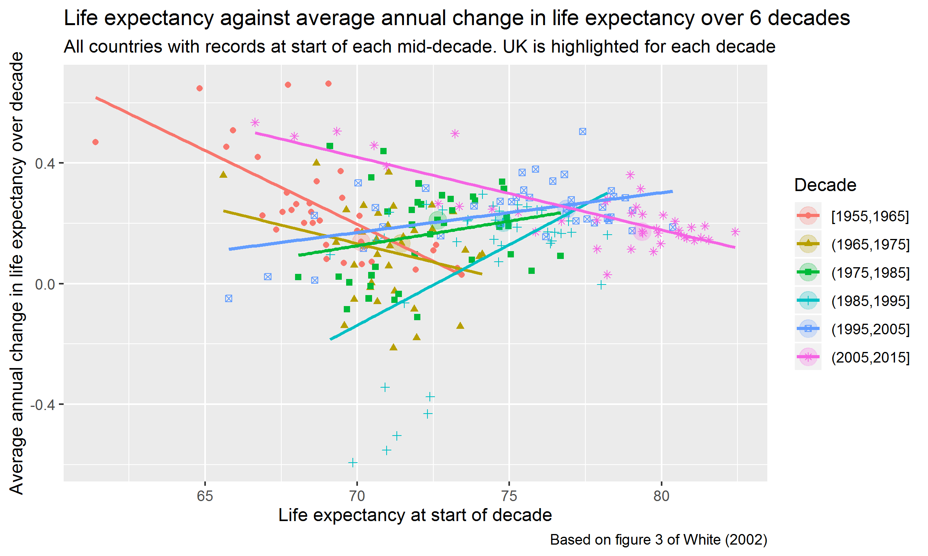

Figure 2 graphs the life expectancy at the start of each decade, against the annual change in life expectancy over the decade, for all the countries in the HMD for which data was available. As described in our methods, this will likely be skewed given that unweighted averages are shown and good quality data was not available for a number of countries until the mid-1980s. It is not possible to draw conclusions from this presentation of the available data.